**Stock Price Movement**

**Analysis Report**

**Prepared by:** Urvi Gupta  
 **Date:** 10-03-2025  
 **Subject:** Stock Analysis

**Introduction**

Stock market analysis is essential for investors, traders, and researchers to understand price trends, make informed decisions, and predict future stock movements. In this report, we analyze the stock price movement of a selected stock using Python. The analysis includes fetching historical stock data, calculating the moving average, and visualizing the stock trends with graphical representation.

**Methodology**

The methodology followed in this report includes:

1. **Data Collection:** Using the yfinance library to fetch stock price data.
2. **Data Processing:** Cleaning and computing the Moving Average (MA) for the stock prices.
3. **Visualization:** Using matplotlib to generate a graphical representation of the stock's performance.
4. **Evaluation:** Observing stock price trends over the selected period.

**Code**

import yfinance as yf

import matplotlib.pyplot as plt

import pandas as pd

# Function to fetch and plot stock data

def plot_stock_movement(stock_symbol, start_date, end_date, ma_window=5):

# Fetch historical data

stock_data = yf.download(stock_symbol, start=start_date, end=end_date, interval="1d")

if stock_data.empty:

print("No data found for the given stock symbol and date range.")

return

# Calculate moving average

stock_data['MA'] = stock_data['Close'].rolling(window=ma_window).mean()

# Plot closing price and moving average

plt.figure(figsize=(12, 6))

plt.plot(stock_data.index, stock_data['Close'], label='Close Price', color='blue')

plt.plot(stock_data.index, stock_data['MA'], label=f'{ma_window}-Day Moving Avg', color='red', linestyle='dashed')

plt.xlabel('Date')

plt.ylabel('Stock Price')

plt.title(f'{stock_symbol} Stock Price Movement')

plt.legend()

plt.grid()

plt.show()

# Example usage

stock_symbol = "AAPL" # Change this to your preferred stock symbol

start_date = "2024-02-01"

end_date = "2024-03-01"

plot_stock_movement(stock_symbol, start_date, end_date)

**Output:**

screenshot of the generated stock price movement graph->

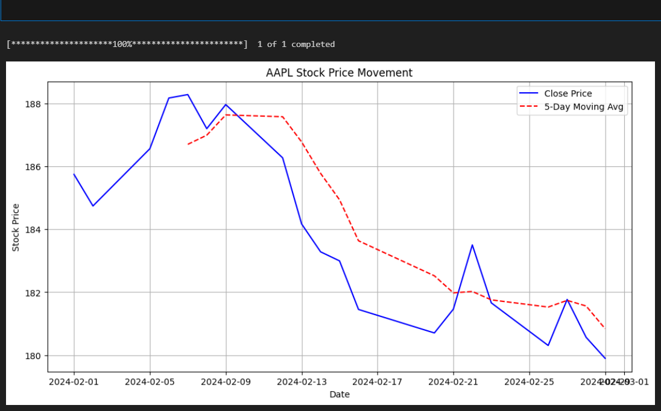

**Conclusion**

This report demonstrates how Python can be used for financial data analysis, specifically for stock price movements. Using **yfinance** for data extraction and **matplotlib** for visualization, we were able to track stock price trends and their moving averages. This analysis helps investors and analysts gain insights into stock performance, assisting in better decision-making.